http://wiki.stat.ucla.edu/socr/index.php/SOCR_Courses_2008_Thomson_ECON261

Continuous Probability Distribution and the Standard Normal Probability Distribution

By Grace Thomson

Continuous Probability Distributions:
There are two widely known continuous distributions: the Normal Probability Distribution and the Standardized Normal Distribution:

Normal Probability Distribution
Most of the outputs from many processes in life are normally distributed, e.g. Age distribution of students in a classroom; height distribution of members of a football team, etc.

50% area under curve
Age
Mean=Md=Mo

Characteristics
- Bell shaped
- Unimodal → peaks at a single value
- Symmetrical → one side is mirror of the other (Mean=Md=Mo)
- Asymptotic → Left and Right side of the curve is asymptotic to x-axis
- Width → Determined by amount of variation of random variable.
- This is not used in business → replaced by Standardized Normal Distribution.
Its main disadvantage is its complexity for numerical computations and real-life applications. That’s when we use the Standard Normal Distribution, explained below.

How to compute Normal Probability Distributions Using SOCR

Go to SOCR Distributions (http://socr.ucla.edu/htmls/SOCR_Distributions.html)

Select “Normal Distribution”, set parameters, Use mouse (or enter values manually in the bottom-right text areas) to choose the region of interest as shown on the image below:

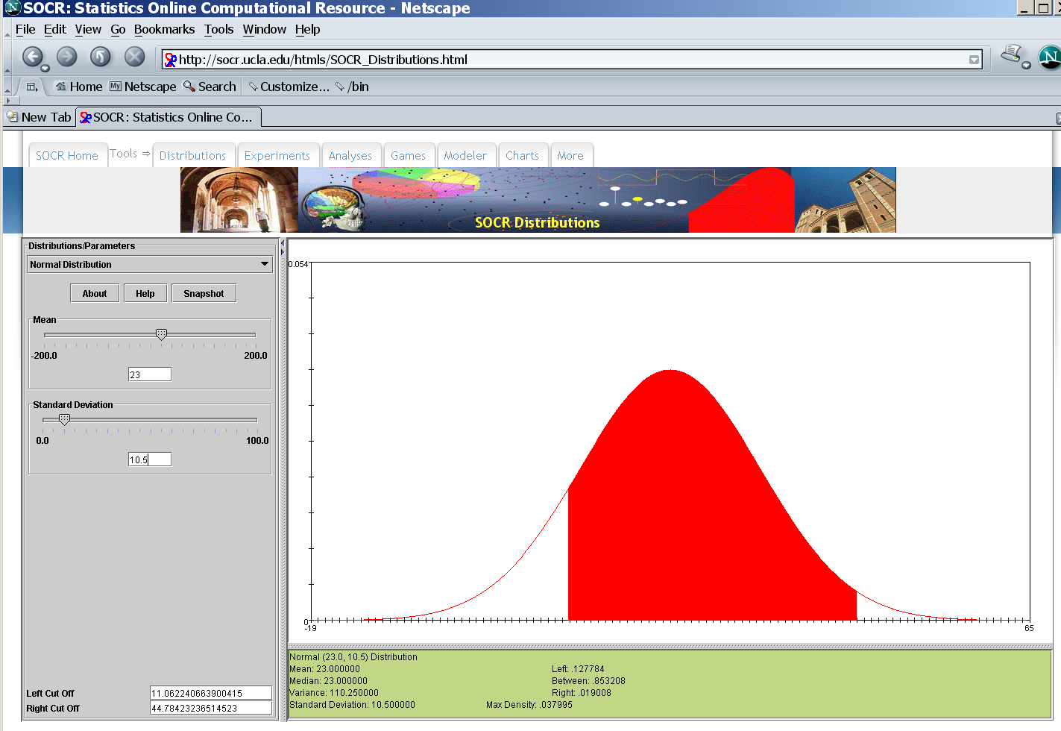

In excel:
In order to compute what is the probability that a given event occurs, we may assume that the even behaves as a Normal distribution, this is, that the distribution is bell shaped and symmetric.
To operate the formula we only need to type the following formula in excel and fill in the information that is requested:
=NORMDIST(x, mean, standard_dev, TRUE)
It will yield the cumulative probability to the left of the number that you are interested in assess. Let’s say that you have a portfolio of customers whose annual expenditure behaves as a normal distribution, and you want to know what is the probability that within your data set, you select one customer with an earning of 100,000? To answer this, first you need to do the following:.
- Determine mean μ, and the standard deviation, σ of your data set
- Define your event of interest, e.g. probability of earning more than 100,000
- fill in the information =NORMDIST(x, mean, standard_dev, TRUE)

Application of Normal Distributions to a Business Problem
Company X knows that mean of earnings of firms in their industry is $200,000 and needs to know the probability that in a given quarter the earnings of the company be less than $100,000, P(X < 100,000) with an industry standard deviation of $80,000.
=normdist(x,mean,stddeviation,true)
=normdist(100000,200000,80000,true)= 0.105649
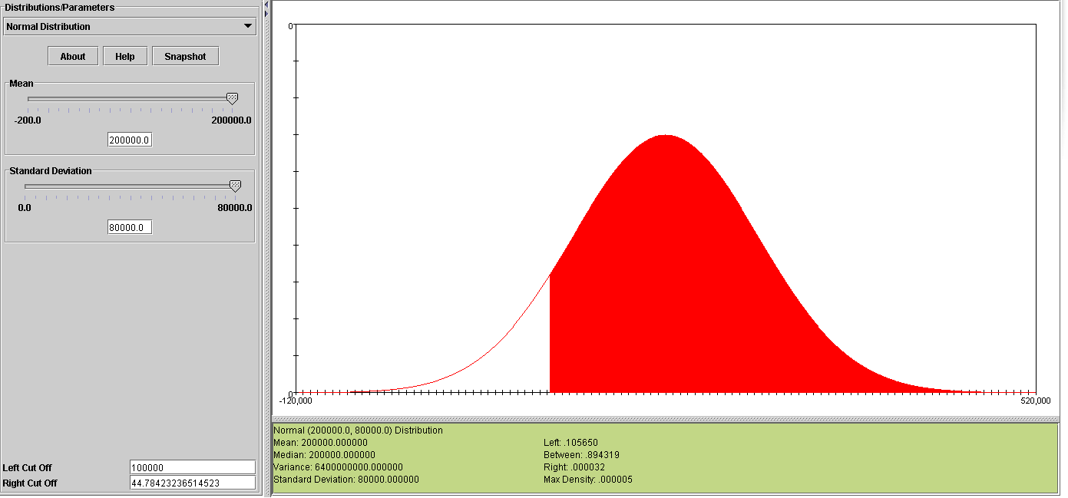
Representing this example in a distribution curve we would have:

Normal distribution of Earnings in company X in $

P (X<$100,000) = 0.105649
μ= 200,000
Let’s practice with information from your workplace
$
100,000

Standard Normal Distribution

Based on the normal distribution but presented in a more flexible and friendly distribution. Its main characteristic is that this distribution has a mean μ = 0 and σ = 1

50% area under curve
+Z
-Z
0

Characteristics | - Bell shaped  - Unimodal → peaks at a single value  - Symmetrical → one side is mirror of the other (Mean=Md=Mo)  - Asymptotic → Left and Right side of the curve is asymptotic to x-axis  - Width → Determined by Z and σ

The X-axis is measured in Z units, a non-measurable unit that expresses the number of standard deviations a number is from the mean, instead of using inches, meters, minutes, and so forth.
The formula to convert the normal distribution to a Standard Normal Distribution is very simple. Z is computed as the difference between a given value x and the mean divided by the standard deviation.

Z = X - μ
σ
Standardized normal Z value →Rescales $, pounds expressing it as Z

+Z
-Z
μ

For example, what is the z value of a distribution where the mean is $200,000, the standard deviation is $80,000 and x= 100,000?
Z = 100,000 - 200,000= -0.125
80,000

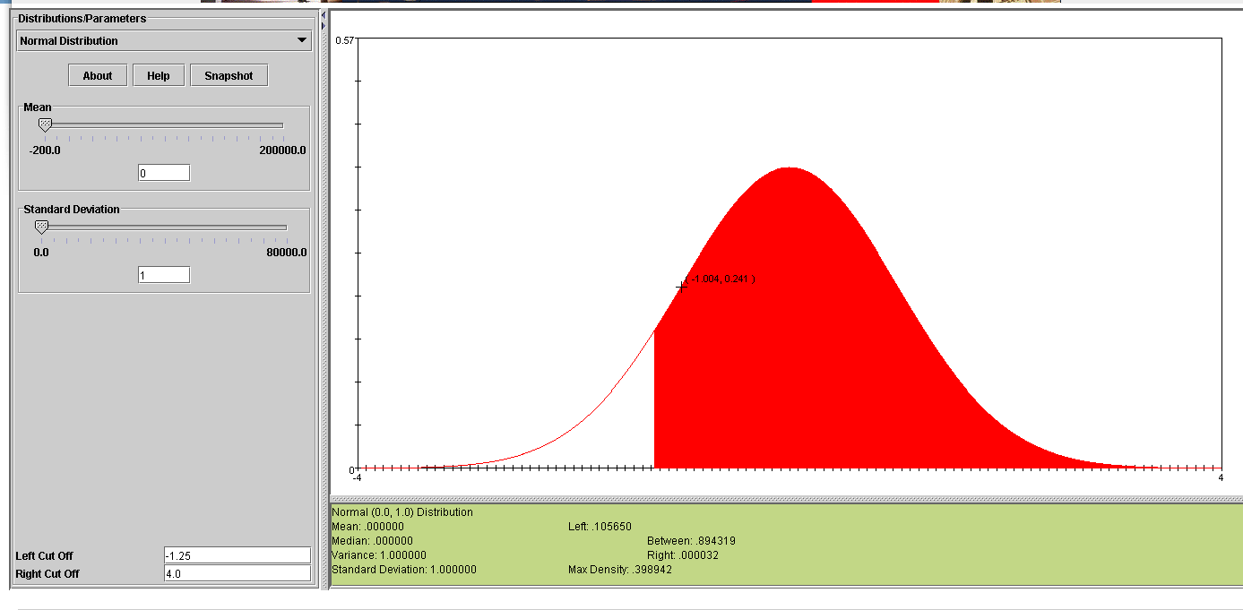

How to compute Normal Probability Distributions in excel?
Now we can compute the probability distribution of any event of interest using excel.
= NORMSDIST(Z)
It will yield de cumulative probability of a value less or equal to Z. We need to compute this Z.
- Determine mean μ, and the standard deviation, σ
- Define event of interest, such as Probability of earnings less than $100,000 , etc.
- Convert the normal distribution to the standard normal distribution using →
Z = X - μ
σ

- Apply the formula to compute probabilities according to the case

P(Z< Zi) = NORMSDIST(Z)
P(Z> Zi) = 1 - NORMSDIST(Z)
P(Z < 0) = 0.50
P(Z > 0) = 0.50

Application of the Standardized Normal Distribution to a Business Problem
Company X knows that mean of earnings of firms in their industry is $200,000 and needs to know the probability that in a given quarter the earnings of the company be less than $100,000, P(X < 100,000) with an industry standard deviation of $80,000.
- Determine mean μ, and the standard deviation, σ μ= $200,000, σ= $80,000
- Define event of interest: P(X < 100,000)
- Convert the normal distribution to the standard normal distribution using →
Z = 100,000 - 200,000 = -1.25
80,000

So, P(X< 100,000) is the same as saying P(Z< -1.25)
- Apply the formula. =NORMSDIST(-1.25) = 0.1056 The same probability as before.
Representing this example in a distribution curve we would have:

Standard Normal distribution of Earnings in company X in $

P (X<$100,000)= P(Z< -1.25) = 0.105649
μ= 0
-1.25
100,000
LEARNING TEAM ACTIVITY

Suppose that the quarterly price, x, of the stock of Company X is Normally distributed with mean μ=$2.0 and with standard deviation σ = 1.20; What is the probability that in randomly chosen quarters the following happened:

P(x< 3.2)=
P(x> 3.2)=
P(x > -3.2)=
P( 4 >x > -3.2)=
SOCR Learning Materials for Normal Distribution:
http://wiki.stat.ucla.edu/socr/index.php/SOCR_EduMaterials_Activities_Distributions
http://wiki.stat.ucla.edu/socr/index.php/SOCR_EduMaterials_Activities_Normal_Distributions
http://wiki.stat.ucla.edu/socr/index.php/SOCR_EduMaterials_Activities_Normal_Probability_examples

