http://wiki.stat.ucla.edu/socr/index.php/SOCR_Courses_2008_Thomson_ECON261

DESCRIPTIVE STATISTICS

PART II DESCRIBING YOUR DATA USING NUMERICAL MEASURES


Grace S. Thomson

BUSINESS RESEARCH AND DESCRIPTIVE STATISTICS
PART II DESCRIBING YOUR DATA USING NUMERICAL MEASURES

This chapter contains 3 main topics related to available techniques to describe and interpret statistic data, using numerical measures of center, location, and variation.

- Measures of Center and Location
- Measures of Variation
- Describing and comparing measures
Let me summarize what you will find in this chapter: Remember when you learned about nominal and ordinal data? Now we are going to use these concepts to understand what type of measurement is suitable to describe data.
Our first concept is the difference between a parameter and a statistic. When you are measuring data from the entire population, you are calculating a parameter, whereas when measuring data from a sample, you are calculating a statistic (Lind, 2005). It is important to keep these 2 concepts in mind all the time, because you will see them repeatedly through our class.

Types of Measurements
In statistics there are basically 2 types of measurements: a) measures of location and b) measures of variation
This book addresses seven measures of location and six measures of variation. At the end of the chapter you will learn how to integrate these measures in five indicators to reach conclusions about the data. Let’s start summarizing them in the following tables:

Measures of location
1. Measure of Central Tendency
- Population Mean
- Population /Sample
- Median
- Mode
2. Other Measures of location
- Weighted Mean → population/ sample
- Percentiles
- Quartiles
Measures of variation
- Range
- Interquartile Range
- Population Variance
- Sample Variance
- Population Deviation
- Sample Deviation
Mean and standard deviation combined
- Coefficient of Variation for Population
- Coefficient of Variation for Sample
- Empirical rule
- Tchebysheff’s Theorem
- Standardized Data Value

Measures of Location
Mean
Let’s say that you need to express the average annual income of your 1000 customers. That number is called the mean, and since you compute it from the totality of your customers you will be calculating a population mean. If you take only a sample you will be using a sample mean.
Procedure: Very simple, divide the sum of the values by the number of values in the data. Let’s use this example to understand the concept. Following there is a record of revenues in dollars per month from a retail store.

Table 1
Monthly Revenues for a Retail Store
January-September 2xx7
Months | Revenue in dollars
January | 25,000
February | 28,000
March | 35,000
April | 32,000
May | 40,000
June | 50,000
July | 38,000
August | 40,000
September | 32,000
Total | 320,000
n= | 9
Mean= | 320,000/9 = 35,556

Notice how we divide the total revenue for the nine months by the number of months. If this is all the data we have $35,556 is the mean or average of the population. The formula we use in statistics is:

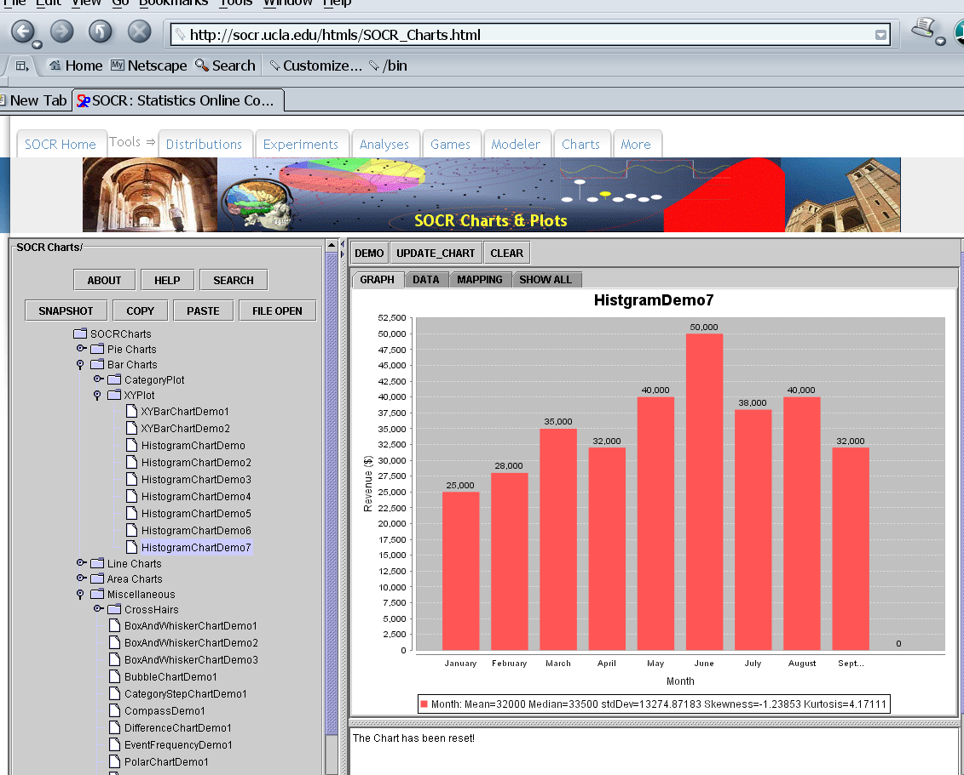

Where Σ means sum, and the notation under and over it, means that the sum operates from the observation number one to the last observation (N). Xi represents all the observations i that our problem has. N represents the count of observations of our problem.

Population Mean

Sample mean
Notice I have cited two formulae: One is for the population mean and the other for the sample mean. The population mean μ) formula has all capitalized characters while the sample mean has all the characters in lower case.
So using our example, your population mean is $35,556 if we consider all the months in the list. But what if you choose a sample of the revenues of 3 random months? Let’s say that you chose March, June and September to compute the average:
Table 1
Monthly Revenues for a Retail Store
March- September 2xx7
Months | Revenue in dollars
March | 35,000
June | 50,000
September | 32,000
Total | 117,000
n= | 3
Mean= | 117,000/3 = 39,000

Notice that the mean is now $39,000 because we chose 3 of the highest monthly revenue, by coincidence.
I have good news for you, using MSExcel makes it easy to compute the mean, as easy as 1-2-3. The formula to compute the mean is “=average(range)”.

Median
However if what you are more interested in finding out is their mid-point income, you need to calculate the MEDIAN. It will give you the number for which at least half of the data are at least as large as the data value, and at least half of the data are as small as or smaller than that data value.
Procedure: Simply, arrange data in numerical order from smallest to largest (data array), and locate the value halfway from either end, that’s your median. To locate this number divide the number of observations plus 1 by 2, like this (N+1)/2

Here a quick example: If you have a sample of 21 customers with their billing information and you want to know the median amount of billing in your portfolio, you will arrange all your customers from the lowest to the highest amount and then locate the client who is in the 11th position -since (N + 1) /2= 11. The amount of billing that this customer had is the median of your portfolio. If his billing amount is $50,000 in a year, $50,000 is the median, which means that 50% of your portfolio has billings above it and 50% of your portfolio has billings under it.
If your portfolio contained 20 customers, the median would be located between the 10th and 11th position since (20+1)/2= 10.5 and you would need to compute an average between those two middle numbers.

Mode
If you are interested in the most repeated annual income among your potential customers, that number is called the MODE.
Procedure: Lay out your information and identify the most frequent value in the list. That is the mode. Some data sets have two or more modes in which case it’s said that the sample or population is multimodal; others have no repeated numbers, so no mode for that data set. Now, be careful because the mode is given by the repeated number, not by the repetitions. So if in your customer portfolio $70,000 is repeated 6 times, $70,000 is the mode of your portfolio, not 6; 6 is the indication of the number of customers who have amount.

Skewness and Symmetry
Now, let’s take a look at other 2 important concepts –Skewed and Symmetric distributions. Data sets are symmetric when their values are evenly spread around the center, and to confirm this, median and mean must be equal. Take a look at the following curve:
Mean = Median

Frequency
x
When this doesn’t happen, data might be left-skewed distributed →the mean is smaller than (to the left of) the median. Or right-skewed distributed → the mean is larger than (to the right of) the median.
Here is another concept to remember: The mean can be highly affected by extreme values. If one of the observations has very low or very high values, it affects the mean ma king it lower or higher, respectively.
Notice the Mean, Median, Skewness and Kurtosis measures on bottom of most SOCR Charts (http://socr.ucla.edu/htmls/SOCR_Charts.html)
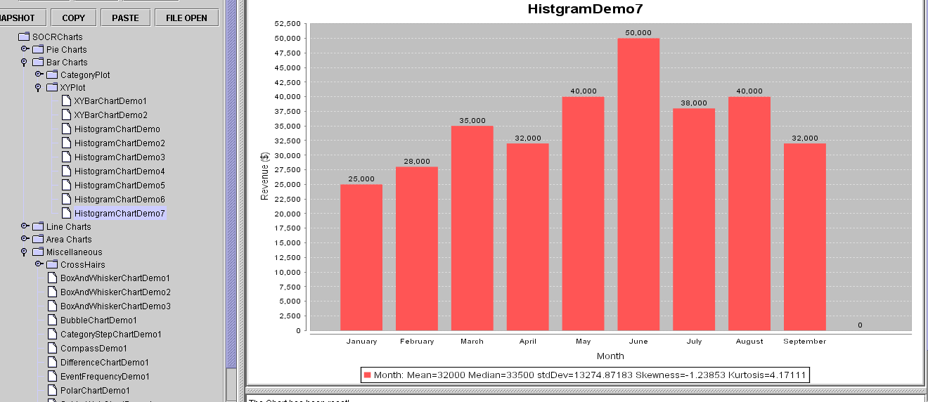

Other measures of location
Weighted mean is a measure of location used when there is a relative importance of each value in the data. It’s also called mean for grouped data.
Procedure: Collect the data and assign weights to each observation, multiply each weight by the data value and sum them. Sum the weights, too. Then divide the first sum by the sum of weights and you’ll have the weighted mean:
You can compute weighted mean for populations and samples. We will go over this with an example in class.

Weighted Mean for a population

Weighted Mean for a sample
The difference between these 2 formulas is simply the source of information and the symbol for the weighted mean (μ) or X bar.

Percentiles
It’s a measure of position expressed in percentage up to 100%. It divides the data in two segments: At p% a value is as large or larger than that p% and smaller than the remaining (100-p%) . e.g. If you are in the 90th percentile of your class, it means that your score is as high or higher than 90% of the class, and lower than 10% of the class. So, that’s good, the higher the percentile, the better.
Procedure: Sort data from low to high, then assign a location indicator from 1 to n to each data value. Apply the formula for percentiles to locate the percentile you are interested in:
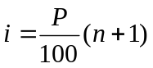
P= desired value
n= number of values in data set
e.g. If there are 20 students in your class, and you are in the 90th percentile of the class based on the grades, by replacing the 90 in the formula you will find out that you are in position 18.90 However decimals don’t make much sense for a location, so we need to interpolate to locate the exact position of your grade. If the grade in position 18 is 98, and the grade in position 19 is 98.5, the interpolation would result in a score of 98.45 (98 + 0.90*(98.5 – 98)], that’s your positional score.

Quartiles
Works similarly to the percentile, with the difference the percentage divides the data set in four equal-sized groups. There is a relationship between quartiles and percentiles:
Table 3
Relationship between quartiles and percentiles
1st. quartile→ | 25th percentile
2nd. quartile→ | 50th percentile MEDIAN
3rd. quartile→ | 75th percentile
4th. Quartile→ | 100th percentile

Notice that the 2nd quartile, or 50th percentile is the same as the median.
Quartiles operate with the same formula for percentiles.
P= desired value
n= number of values in data set

Box and Whiskers plot
This is a descriptive tool that allows graphic observation of the distribution of the data. Any value outside the limits of this box is considered an outlier.

Procedure: Sort data from lower to high. Calculate Q1(1st. quartile), Q2 (2nd. quartile), Q3 (3rd. quartile) and build a box with ends located at Q1 and Q3. A vertical line through the box is placed at the median (Q2). Limits are set up at each side, by calculating the interquartile range (IQR = Q3-Q1) and multiplying it by 1.5 times. Dashed lines (Whiskers) are drawn within these limits. Numbers outside these limits are marked with an asterisk (*)
* *
*
outliers

Using SOCR to Get Box Plots

Go to SOCR Charts (http://socr.ucla.edu/htmls/SOCR_Charts.html) and select one of the BoxAndWhisker’s Plots ← Miscellaneous:
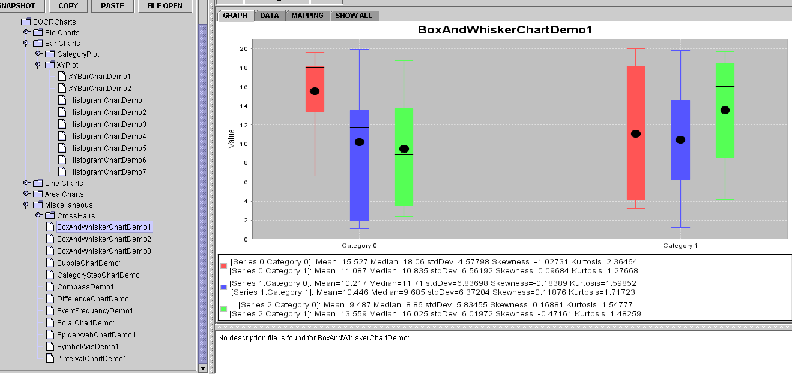

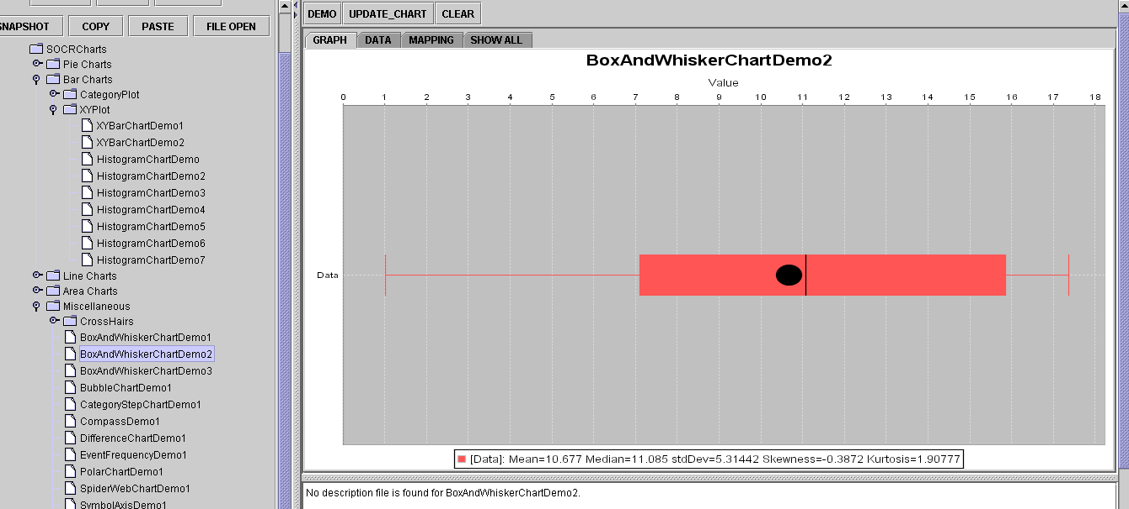

Measures of variation
If all the data are not the same value you have got VARIATION, isn’t it an easy concept? Sometimes 2 data sets may have the same mean, but variation (or behavior) of their observations is different making one set more stable than other.
When measuring variation you may use any of the following 6 measures:

Range
Difference between maximum and minimum value in a data set:
R = Maximum value – Minimum value
It’s useful when we want to have an idea of what is the general composition of the data, and how apart our maximum and minimum is.

Interquartile Range
Difference between 3rd and 1st quartile. It’s not affected by extreme values, more efficient than Range.
IQR = Third Quartile – First Quartile
This range measures the information grouped within 25% and 75% of the data set, leaving out the data above and below the limits. It’s more accurate than the range, but still presents an important weakness: None of these two formulae use all the data for computations. To overcome this difficulty the following measures were created:

Population Variance
This is one of the most common measures of variation in Statistics. Many of the concepts that we will learn in the future regarding probabilities and hypothesis tests, rely on the accurate computation of the variance.
Variance is the average of the squared variations from the mean. As the formula suggests below, it’s necessary to compute the difference between each value and the mean, then square that difference and finally add up all this variations and divide them by the total number of observations.
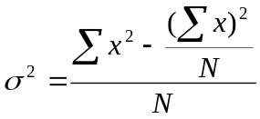
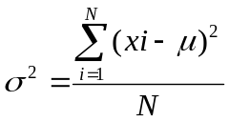

Population Standard Deviation
Square root of Variance, explains how spread out a distribution is, and it’s very useful to make comparisons between data sets with the same mean. If distributions have the same mean, the one with the largest standard deviation has the greatest relative spread.
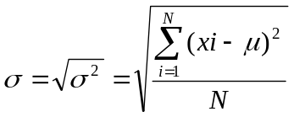

Sample Variance
The formula is similar to population variance, but notice that the denominator is n-1. The source of the information is a sample and not the entire population. Notice also that the variables are written in lower case and the mean is expressed by x bar and not μ.
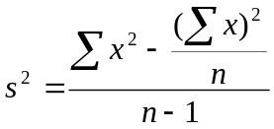
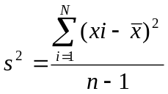
= sample mean
n = sample size
s² = sample variance

Sample Standard Deviation
Square root of Sample variance:
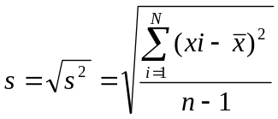
= sample mean
n = sample size
s² = sample variance

Using Excel to compute measures of location and variation

Most SOCR Charts (http://socr.ucla.edu/htmls/SOCR_Charts.html) compute the main measures of centrality and variation. Now that you have learned the operational part of computing measures of location and variation, we will take a quick look at a tool provided by Excel to help us in this process. It’s the Data Analysis option. We can request a Summary Statistics report using the following commands:
- Open Excel
- Click on TOOLS menu
- Click on DATA ANALYSIS
- Click on DESCRIPTIVE STATISTICS
- Follow the prompts and select the range with the data you want to input
- Click on SUMMARY STATISTICS
- Click OK
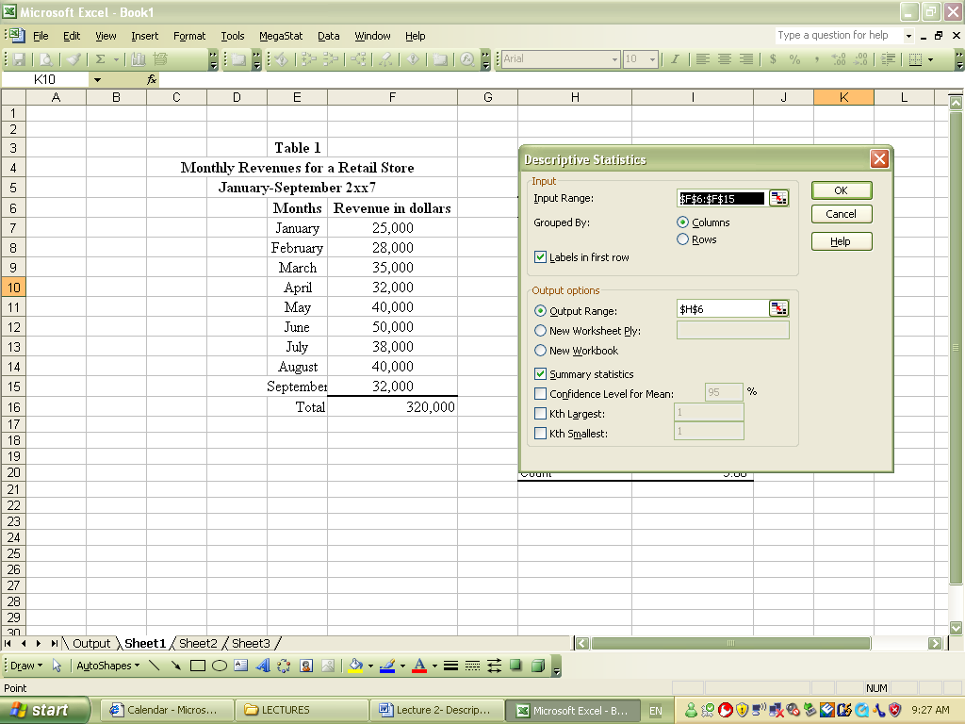

A table with all the information about: Mean, Median, Mode, Standard Deviation, Sample Variance, Range, Minimum, Maximum, Sum, Count will appear. You will be able to compare samples, populations and make a more informed decision about the variation or stability of the data set.
Revenue in dollars
Mean | 35,555.56
Standard Error | 2,495.06
Median | 35,000.00
Mode | 32,000.00
Standard Deviation | 7,485.17
Sample Variance | 56,027,777.78
Kurtosis | 0.58
Skewness | 0.58
Range | 25,000.00
Minimum | 25,000.00
Maximum | 50,000.00
Sum | 320,000.00
Count | 9.00

Note: When inputting the information in the Input range cell, make sure that you include only quantitative data. The software will warn you that you can’t input qualitative data. In the case of our exercise, the months listed on the table are qualitative data.
We can also use MEGASTAT to compute the descriptive statistics; proceed as follows:
- Click on MEGASTAT from the menu options
- Click on Descriptive Statistics
- Input the range on the window
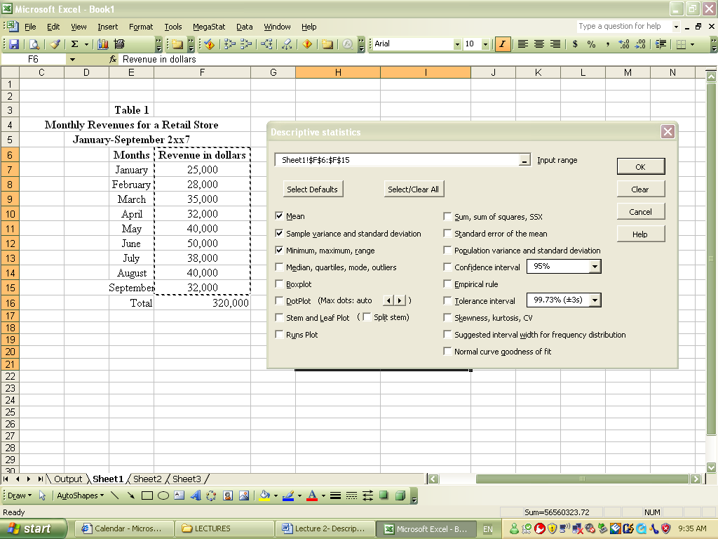
- Choose the measurement tools you need: Sample mean, variance, percentiles, box and whisker plots, etc.
- Click ok

The following report is prepared by MEGASTAT, scroll down and see how many of these you can recognize:

Descriptive statistics
 | Revenue in dollars
count | 9
mean | 35,555.56
sample variance | 56,027,777.78
sample standard deviation | 7,485.17
minimum | 25000
maximum | 50000
range | 25000
population variance | 49,802,469.14
population standard deviation | 7,057.09
empirical rule
mean - 1s | 28,070.39
mean + 1s | 43,040.73
percent in interval (68.26%) | 66.7%
mean - 2s | 20,585.21
mean + 2s | 50,525.90
percent in interval (95.44%) | 100.0%
mean - 3s | 13,100.04
mean + 3s | 58,011.07
percent in interval (99.73%) | 100.0%
1st quartile | 32,000.00
median | 35,000.00
3rd quartile | 40,000.00
interquartile range | 8,000.00
mode | 32,000.00
low extremes | 0
low outliers | 0
high outliers | 0
high extremes | 0
Stem and Leaf plot for | Revenue in dollars
stem unit = | 10000
leaf unit = | 1000
Frequency | Stem | Leaf
2 | 2 | 5 8
4 | 3 | 2 2 5 8
2 | 4 | 0 0
1 | 5 | 0
9
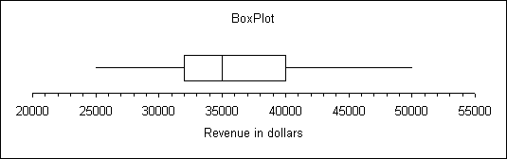

 |  |  | 1/10/2007 9:37.00 (1)

Notice that in this report there are some new measurement tools: The empirical rule and the stem and leaf table. Read more about the empirical rule below.

Combining measurement tools
In this section we will combine the measurements of location and the measurement of variation and use it for applications in business.

Coefficient of Variation (CV)
This indicator combines the standard deviation and the mean in a very useful measure that provides information about variation of data sets, when their means are different. There is a coefficient of variation for population and for samples; their only difference is the type of standard deviation used.
CV = σ/μ (100)
Population CV
CV =s/
(100)
Population CV

The Empirical Rule
Combines information about (μ) and (σ), to explain approximately how much information in your data set is contained within a specific range. This is a very useful indicator for decision makers, because it identifies the outliers or extreme elements of our data. Refer to the table below. The table says that in a normal distribution of values, 68% of the observations will be contained in a range of one standard deviation from the mean. 95% of the observations are within 2 standard deviations from the mean, and virtually all the data values should be within 3 standard deviations from the mean.
Table 4
The empirical Rule
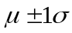 | Contains approx. 68% of the values
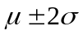 | Contains approx. 95% of the values
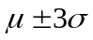 | Contains virtually all of the data values
Note: Frequency distribution must be bell-shaped and symmetric to apply this rule.
Let’s use the information from the MEGASTAT report.
empirical rule
mean - 1s | 28,070.39
mean + 1s | 43,040.73
percent in interval (68.26%) | 66.7%
mean - 2s | 20,585.21
mean + 2s | 50,525.90
percent in interval (95.44%) | 100.0%
mean - 3s | 13,100.04
mean + 3s | 58,011.07
percent in interval (99.73%) | 100.0%

According to this report, 66.7% of the data is located within 1 standard deviation from the mean, this is between 28,000 and 43,000; 100% of the data is within 2 standard deviations from the mean, this is between 20,600 and 50,500 and 100% of the data is within 3 standard deviations from the mean, this is between 13,100 and 58,000. This implies that there are not outliers in this data set, because one hundred percent of the data is included within 3 standard deviations.
Now, how do you use this knowledge? Let’s say that next month you have a customer with a billing amount of $62,000, he is definitely an outlier in this distribution, because he is over the 3 standard deviations from the mean.

Tchebysheff’s Theorem
Very similar to the Empirical rule, with the only difference that frequency distributions doesn’t need to be bell-shaped and symmetric to apply this rule.
The table below states the ranges of validity of Tchebysheff’s theorem.
Table 5
Tchebysheff’s Theorem

Contains approx. 0% of the values
Contains approx. 75% of the values
Contains approx. 89% of the values

Standardized Data Values
The standardization of data values is a procedure that we will use intensively in the following chapters and it allows comparisons between data sets with completely different data scales (e.g. prices for an article expressed in dollars vs. prices expressed in pesos; scores based on 100 points vs. scores based on 20 points).

To standardize a value is to express the value in terms of the number of standard deviations from the mean. Also called z values:
The formula to be used to standardize is very simple:

Standardized population data
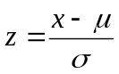

X= original data value
μ = population mean
σ= population standard deviation
Z= standard score (number of standard deviation x is from μ)

A standard value Z is expressed in terms of standard deviations. So for example

Standardized sample data
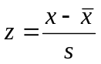

How do we use the concept? Let’s say that you are comparing the billing portfolio of branch 1 and branch 2, and you want to analyze which branch has more dispersion of data. A very good way to do it is by computing Z values, and then compare them.
Always remember to practice the suggested problems in each section of the chapter.
Practice, practice, practice!! Statistics is so useful and these first 3 chapters are the cornerstone of the rest of your class.

SOCR Tools for Exploratory Data Analysis (EDA):

The links below provide additional help and instructions on how to use SOCR for EDA:

wiki.stat.ucla.edu/socr/index.php/SOCR_EduMaterials_Activities_Histogram_Graphs
wiki.stat.ucla.edu/socr/index.php/SOCR_EduMaterials_Activities_BoxPlot
wiki.stat.ucla.edu/socr/index.php/SOCR_EduMaterials_Activities_BarCharts_CategoryPlot
wiki.stat.ucla.edu/socr/index.php/SOCR_EduMaterials_Activities_PieChart
wiki.stat.ucla.edu/socr/index.php/SOCR_EduMaterials_Activities_IndexChart
wiki.stat.ucla.edu/socr/index.php/SOCR_EduMaterials_Activities_StatisticalLineChart

See you in class!

